📌 Amazon S3 Overview (Simple Storage Service)
Amazon S3 (Simple Storage Service) is an object storage service that allows you to store and retrieve any amount of data from anywhere on the internet. It is highly scalable, durable, and secure, making it suitable for various use cases like backup, data lakes, hosting, and big data analytics.

🔹 Key Features of Amazon S3
1️Storage Classes (Cost Optimization)
S3 offers different storage classes based on access frequency & cost:
✅ S3 Standard → For frequently accessed data (low latency, high throughput)
✅ S3 Intelligent-Tiering → Automatically moves data to cheaper storage classes
✅ S3 Standard-IA (Infrequent Access) → For long-lived but infrequently accessed data
✅ S3 One Zone-IA → Cheaper than Standard-IA but stored in only one AZ
✅ S3 Glacier → For long-term archival storage (retrieval in minutes to hours)
✅ S3 Glacier Deep Archive → Lowest-cost storage for data that is rarely accessed

2️S3 Bucket & Objects
- Bucket: A container for storing objects (files)
- Objects: The actual data stored in the bucket (can be images, videos, logs, etc.)
- Keys: A unique identifier for each object
- Versioning: Maintains multiple versions of an object for recovery

3️Security & Access Control
- IAM Policies → Manage user permissions to access S3
- Bucket Policies → Control access at the bucket level
- Access Control Lists (ACLs) → Grant permissions to users or accounts
- S3 Block Public Access → Prevents accidental public exposure of data
- Encryption (S3 Default & KMS) → Encrypts data at rest and in transit

4️Data Management & Performance
✅ Multipart Upload → Upload large files in parts for better efficiency
✅ Replication (Cross-Region & Same-Region) → Copies data for disaster recovery
✅ Lifecycle Policies → Automatically move objects to cheaper storage classes
✅ Object Lock & Versioning → Prevent accidental deletion & recover older versions
✅ Event Notifications → Trigger AWS Lambda, SNS, or SQS when an object is created, updated, or deleted

5️Hosting & Integrations
✅ Static Website Hosting → Host static websites (HTML, CSS, JS) directly from S3
✅ Data Analytics & Machine Learning → Integrate with AWS services like Athena, Redshift, and SageMaker
✅ Backup & Disaster Recovery → Store snapshots, logs, and backup data

📌 Common Use Cases of Amazon S3
✔ Backup & Restore → Store application backups & logs
✔ Static Website Hosting → Host front-end websites using S3
✔ Big Data Analytics → Store large datasets for AI & ML processing
✔ Disaster Recovery → Replicate data across regions for high availability
✔ Media Storage & Content Delivery → Store images, videos, and integrate with CloudFront

📌 How to Create an S3 Bucket?
1️ Go to AWS Console → S3
2️Click Create Bucket
3️Enter Bucket Name & Region
4️Choose Public or Private Access
5️Click Create

S3 Security: Bucket Policy
An S3 Bucket Policy is a JSON-based policy that defines permissions and access control at the bucket level. It allows or denies access to AWS accounts, IAM users, or services.

🔹 Key Features of S3 Bucket Policies
✔ Controls access to the entire bucket or specific objects
✔ Allows/denies permissions for IAM users, AWS accounts, or services
✔ Supports conditions (e.g., IP restrictions, MFA authentication)
✔ Prevents unauthorized access using explicit deny rules
✔ Helps enforce encryption, logging, and compliance policies

🔹 How to Add a Bucket Policy?
1️Open AWS Console → S3
2️Select the Bucket
3️Go to the Permissions tab
4️Click Bucket Policy
5️Add the JSON policy and click Save
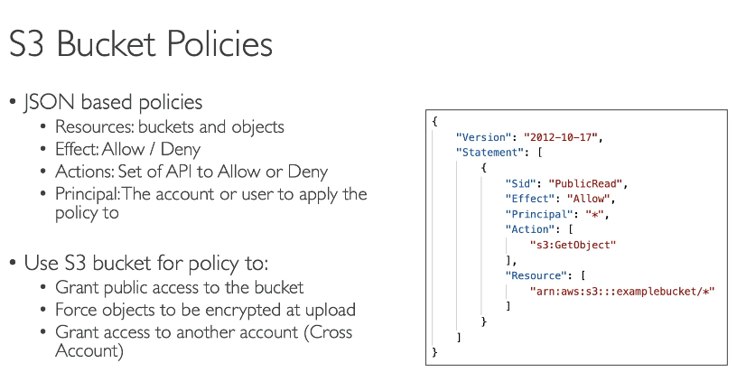

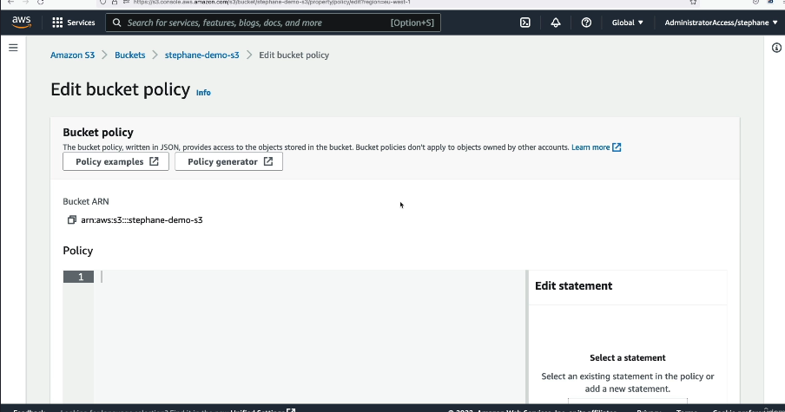

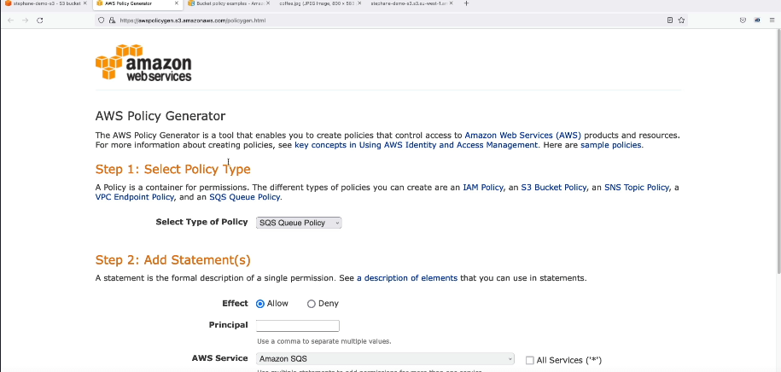

Example S3 Bucket Policies
1️Allow Public Read Access (For Static Website Hosting)
{
"Version": "2012-10-17",
"Statement": [
{
"Effect": "Allow",
"Principal": "*",
"Action": "s3:GetObject",
"Resource": "arn:aws:s3:::my-bucket-name/*"
}
]
}
✅ Use case: Allows anyone to read objects from the bucket.
🔴 Security Warning: This makes your bucket publicly accessible.

S3 Static Website Hosting
Amazon S3 allows you to host a static website (HTML, CSS, JS) without needing a web server like Apache or Nginx. It is a cost-effective, scalable, and highly available solution for hosting simple websites.

🔹 Features of S3 Website Hosting
✔ No servers needed – Fully managed by AWS
✔ Low cost – Pay only for storage and data transfer
✔ Highly available – 99.99% durability
✔ Supports custom domains with Route 53
✔ Integrates with CloudFront for faster performance

📌 Steps to Host a Website on S3
Step 1: Create an S3 Bucket
1️Go to AWS Management Console → S3
2️Click Create Bucket
3️Bucket Name: Must be the same as your domain name (e.g., example.com)
4️Region: Choose the closest region
5️Uncheck "Block all public access" (Important)
6️Click Create Bucket

Step 2: Upload Website Files
1️Click on the created S3 Bucket
2️Open the Objects tab
3️Click Upload → Add your HTML, CSS, JS files
4️Click Upload

Step 3: Enable Static Website Hosting
1️Go to the Properties tab
2️Scroll down to Static website hosting
3️Select "Enable"
4️Index document: index.html
5️Error document: error.html (optional)
6️Click Save

S3 Website Hosting Limitations
🚫 No dynamic content (PHP, Python, or databases won't work)
🚫 No HTTPS by default (CloudFront needed for SSL)
🚫 No server-side processing (Only static files)

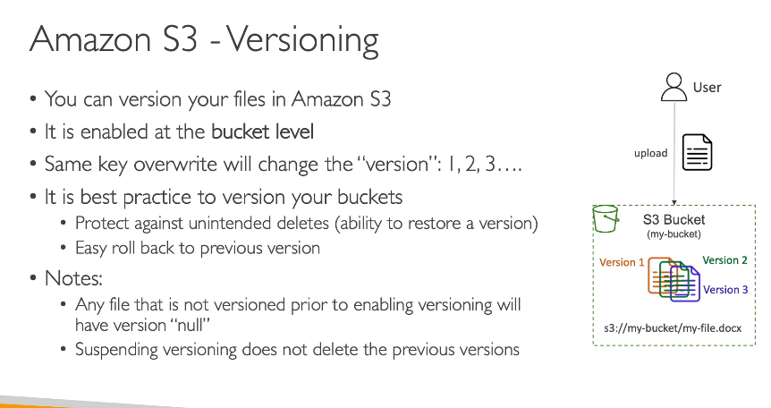

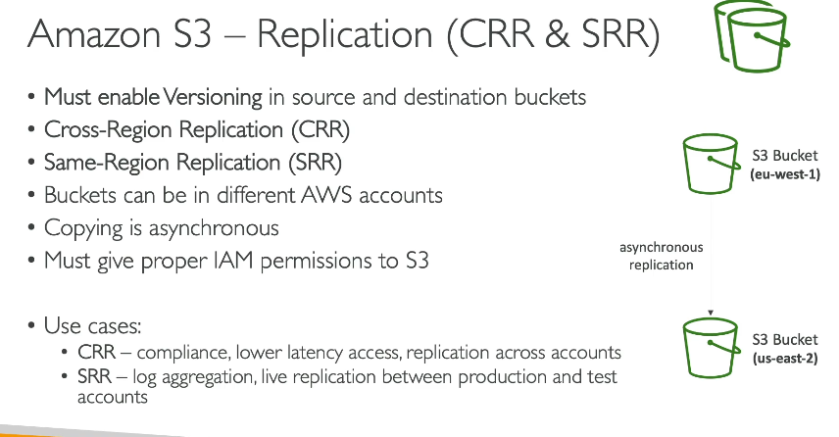
📌 S3 Replication Overview
Amazon S3 Replication allows you to automatically copy objects across different S3 buckets in the same or different AWS regions. It is useful for disaster recovery, data backup, compliance, and latency reduction.

🔹 Types of S3 Replication
✅ Same-Region Replication (SRR) → Replicates data within the same AWS region
✅ Cross-Region Replication (CRR) → Replicates data to another AWS region

📌 How S3 Replication Works?
1️Source Bucket: The original S3 bucket where data is stored
2️Destination Bucket: The S3 bucket where objects are replicated
3️IAM Permissions: The source bucket must allow replication
4️Replication Rules: Define which objects should be replicated
5️Replication Status: Monitored through AWS S3 console or AWS CLI

📌 Steps to Enable S3 Replication
Step 1: Enable Versioning on Both Buckets
- Go to S3 Console → Select your Source Bucket
- Click on Properties → Enable Versioning
- Repeat for the Destination Bucket

Step 2: Set Up a Replication Rule
1️Go to Source Bucket → Click Management
2️Click Create Replication Rule
3️Enter a Rule Name
4️Choose Destination Bucket (same or different region)
5️Select Replication Options:
- Replicate all objects or specific prefixes/tags
- Choose storage class (Standard, Glacier, etc.)
6️IAM Permissions: Create or use an existing IAM Role
7️Click Save

📌 S3 Replication Benefits
✔ Backup & Disaster Recovery → Store data in another region for safety
✔ Compliance & Data Governance → Ensure copies of data exist in multiple locations
✔ Latency Reduction → Users access data from the nearest AWS region
✔ Automatic Copying → No manual intervention needed
✔ Replication to Different Accounts → Increase security by replicating to another AWS account

📌 S3 Replication Limitations
🚫 Does not work on existing objects (Only new objects are replicated)
🚫 One-way replication (Replication is not bi-directional)
🚫 Versioning must be enabled for replication to work
🚫 Deleted objects are not automatically removed in the destination bucket

📌 Advanced Replication Features
🔹 Replicate Objects Across AWS Accounts
🔹 Replicate Specific Prefixes or Object Tags
🔹 Replicate to S3 Glacier for Cost Optimization

📌 Monitoring & Loggin
- Use S3 Replication Metrics (CloudWatch)
- Amazon S3 Event Notifications for replication failures

S3 Lifecycle Rules with S3 Analytics
S3 Lifecycle Rules help you automate data management by transitioning or deleting objects based on defined policies. This optimizes costs and improves storage efficiency.

🔹 Why Use S3 Lifecycle Rules?
✔ Cost Optimization → Move rarely accessed data to cheaper storage
✔ Automatic Data Retention → Delete old objects automatically
✔ Storage Management → Reduce manual work for data transitions
Scenario: You Have a Backup System
Imagine you are managing a backup system where daily logs from your Chat Application (Django, Nginx, MySQL) are stored in Amazon S3.
✅ Problem: These log files are only needed for 30 days. After that, they are rarely used but must be kept for 1 year before being deleted.
✅ Solution: Instead of paying high storage costs, you can use S3 Lifecycle Rules to automatically move old logs to cheaper storage and delete them later.

🔹 How S3 Lifecycle Rules Solve This Problem
1️First 30 Days → Logs are in S3 Standard (fast access)
2️After 30 Days → Move logs to S3 Standard-IA (cheaper storage)
3️After 90 Days → Move logs to S3 Glacier (low-cost archival storage)
4️After 1 Year → Delete logs automatically
👉 This reduces costs and manages storage efficiently without manual effort!

🔹 Step-by-Step Setup in AWS S3
1️Go to the S3 Console
- Open AWS Console → S3
- Click on your S3 Bucket (e.g., chatapp-logs)
2️Create a Lifecycle Rule
- Click Management → Create Lifecycle Rule
- Name the rule: "Move & Delete Logs"
3️Define Conditions
- Apply to all objects OR only logs/ folder
- Set transition rules:
  - Move to S3 Standard-IA after 30 days
  - Move to S3 Glacier after 90 days
  - Delete permanently after 365 days
4️Save and Apply the Rule
- Review and confirm
✅ Done! Now, AWS automatically moves and deletes logs based on your rules.

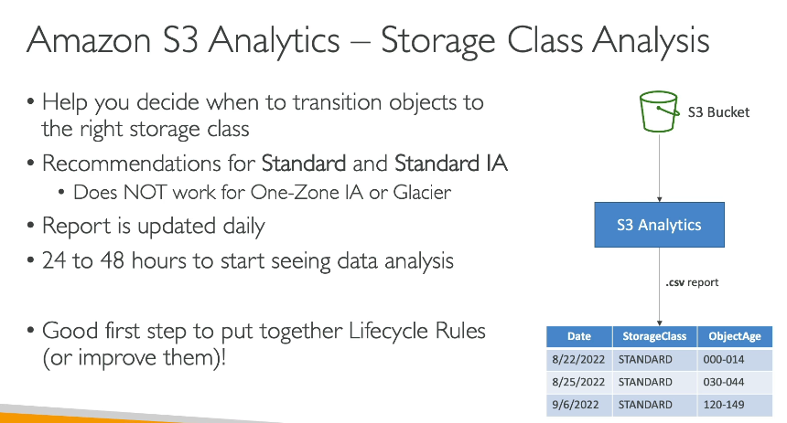

What is S3 Event Notification?
S3 automatically triggers an event when something happens in your bucket. You can use this to notify other AWS services like:
✅ AWS Lambda – Process files automatically
✅ SNS (Simple Notification Service) – Send alerts
✅ SQS (Simple Queue Service) – Queue events for processing

🔹 Real-World Example: Auto-Processing Chat App Profile Pictures
📍 Scenario:
You have a Chat Application (Django, Nginx, MySQL) using S3 to store user profile pictures.
✅ Problem: When a user uploads a new profile picture, you need to resize it for better performance. Doing this manually is slow and inefficient.
✅ Solution: S3 Event Notifications + AWS Lambda
- When a new image is uploaded, S3 triggers an event.
- The event calls an AWS Lambda function to resize the image automatically.
- The resized image is stored back in S3 and used in the chat app.

🔹 Step-by-Step Setup in AWS
1️Enable S3 Event Notification
1️Open AWS S3 Console
2️Go to your S3 Bucket (e.g., chatapp-profile-pics)
3️Click Properties → Scroll to Event Notifications
4️Click Create Event Notification
5️Set the event:
- Name: NewProfilePicUploaded
- Event Type: PUT (Object Created)
- Prefix: profile-pics/ (Only trigger for profile pictures)
- Send to: AWS Lambda

2️Create AWS Lambda Function
1️Go to AWS Lambda Console
2️Click Create Function → Select Author from Scratch
3️Function Name: ResizeProfilePicture
4️Runtime: Python 3.x
5️Permissions: Attach an IAM Role with access to S3 & Lambda Execution
3 Test the Event
1. Upload an image to chatapp-profile-pics/profile-pics/
2. S3 triggers the event → Calls Lambda function
3. Lambda resizes the image → Saves to chatapp-profile-pics/resized/
✅ Done! Now, every uploaded profile picture is automatically resized.

🔹 Other Use Cases for S3 Event Notifications
💡 Log Processing – Auto-process logs when uploaded
💡 Virus Scanning – Scan files using Lambda before allowing downloads
💡 Data Backup – Move files to a different S3 bucket for backup

S3 Request Performance
📌 GET, PUT, DELETE, LIST Request Optimization
- Parallelize Uploads & Downloads
→ Use multipart upload for large files (over 100 MB).
→ Parallelize downloads using range GET requests.
- Use S3 Transfer Acceleration
→ If users upload from different geographic locations, S3 Transfer Acceleration reduces latency.
- Use Amazon CloudFront for Read Performance
→ Cache frequently accessed S3 objects using CloudFront CDN.

🔹 2. S3 Indexing & Partitioning for Performance
- Avoid Hot Prefixes (S3 automatically spreads traffic across partitions)
→ Best practice: Use a random or hashed prefix for keys instead of sequential naming.
✅ Bad Key Design (Hot Prefix Issue)
/logs/2024-03-01/file1.log
/logs/2024-03-01/file2.log
🚀 Good Key Design (Distributed Load)
/logs/7b8d4e-file1.log
/logs/a92c31-file2.log
- Use Byte-Range Fetches for Large Objects
→ Allows parallel downloads of different parts of the file.

S3 Batch Operations - Simplifying Large-Scale Object Management
Amazon S3 Batch Operations lets you process millions or billions of S3 objects in bulk without writing custom scripts or applications. You can perform actions like copying objects, tagging, restoring from Glacier, and invoking Lambda.

Create an S3 Batch Job
1️Open the AWS S3 Console
2️Click on Batch Operations → Create Job
3️Select Manifest File (CSV stored in S3)
4️Choose an Operation (Copy, Tagging, Glacier Restore, etc.)
5️Select an IAM Role with necessary permissions
6️(Optional) Enable Completion Reports
7️Click Create Job → Run Job

Example Use Case: S3 Batch Operations in Your Chat App
💬 Scenario: Auto-Tagging Profile Pictures
Your chat app stores profile pictures in S3. You want to tag all images with "profile-picture: true" for easier management.
🚀 Solution: Use S3 Batch Operations
1️Create a Manifest File listing all profile picture objects.
2️Use the "Add Tags" Batch Operation to apply the "profile-picture: true" tag.
3️All images are now tagged!

🔹 Best Practices for S3 Batch Operations
✅ Use S3 Inventory to generate object lists for large-scale jobs.
✅ Enable Completion Reports to track success/failure.
✅ Use Lambda Invocation for custom data processing (e.g., image resizing).

📌 S3 Inventory - Simplified Object Tracking in Bulk
Amazon S3 Inventory provides a way to list and track all objects in an S3 bucket, including their metadata, encryption status, and storage class. It helps in auditing, managing, and running analytics on stored objects without manually listing them.

🔹 Why Use S3 Inventory?
Scenario |  |  |  |  |  |  |  |  | Example Use Case
Track Unencrypted Objects |  |  |  |  |  |  |  |  | Identify files that need encryption
Monitor Object Metadata |  |  |  |  |  |  |  |  | Check storage class, size, and last modified date
Optimize Storage Costs |  |  |  |  |  |  |  |  | Find and delete old or unused objects
Generate Reports for Audits |  |  |  |  |  |  |  |  | List all objects for compliance audits
Prepare Input for S3 Batch Ops |  |  |  |  |  |  |  |  | Use inventory to create a manifest file

🔹 How S3 Inventory Works
- Generates a report (CSV or Parquet format) with a list of all objects.
- Can be scheduled daily or weekly.
- Stored in an S3 bucket of your choice.
- Supports Athena, Redshift, and Big Data processing.

🔹 Steps to Enable S3 Inventory
Step 1️ Open the S3 Console
1️Navigate to Amazon S3
2️Select your bucket
3️Click on Management → Inventory configurations
4️Click Create inventory configuration
Step 2️ Configure Inventory
✅ Inventory Name – Example: MyBucket-Inventory
✅ Scope – Choose entire bucket or a prefix (e.g., logs/)
✅ Destination Bucket – Select where reports will be stored
✅ Report Frequency – Choose Daily or Weekly
✅ Format – Choose CSV or Parquet
✅ Additional Fields – Select attributes like size, encryption, storage class

Step 3️ Review and Create
- Click Save → The first inventory report will be generated within 24 hours.

🔹 Example Use Case: Tracking Profile Pictures in Your Chat App
💬 Scenario:
Your chat app stores profile pictures in S3, but some images are unencrypted. You need to find and encrypt them.
🚀 Solution: Use S3 Inventory
1️Enable S3 Inventory to generate a list of all objects.
2️Check encryption status in the report.
3️Use S3 Batch Operations to encrypt unencrypted objects.
4 Your chat app is now compliant with security standards!

🔹 Best Practices
✅ Use CSV for small-scale reports and Parquet for big data analytics.
✅ Store inventory reports in a separate bucket for security.
✅ Use Athena or Redshift to query reports efficiently.

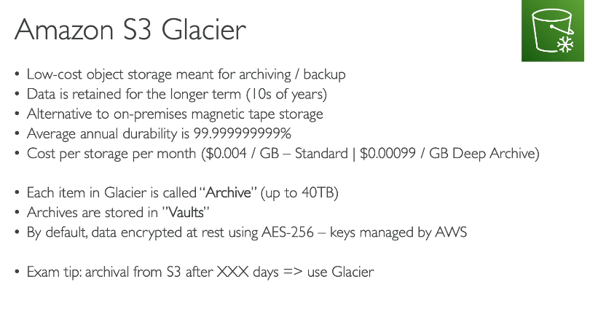
Amazon S3 Glacier is a low-cost, long-term storage solution for archiving data that you don’t need immediate access to but still want to keep safely stored. It is perfect for backups, regulatory archives, and historical records.

🔹 Why Use S3 Glacier?
Scenario |  |  |  |  |  |  |  |  |  |  |  |  |  | Example Use Case
Backup Old Application Logs |  |  |  |  |  |  |  |  |  |  |  |  |  | Store old chat logs from your chat app
Archive Compliance Data |  |  |  |  |  |  |  |  |  |  |  |  |  | Save legal or financial records for 10+ years
Store Rarely Accessed Data |  |  |  |  |  |  |  |  |  |  |  |  |  | Preserve raw images or videos that are rarely needed
Reduce Storage Costs |  |  |  |  |  |  |  |  |  |  |  |  |  | Move large, unused data from S3 Standard

🔹 S3 Glacier Storage Classes
AWS offers different retrieval speeds depending on how fast you need your archived data:
Storage Class |  |  |  |  |  | Retrieval Time |  |  |  |  |  |  | Best For
Glacier Flexible Retrieval |  |  |  |  |  | Minutes to hours |  |  |  |  |  |  | Infrequent access
Glacier Instant Retrieval |  |  |  |  |  | Milliseconds |  |  |  |  |  |  | Archives needing occasional access
Glacier Deep Archive |  |  |  |  |  | Hours (12–48 hours) |  |  |  |  |  |  | Long-term storage (10+ years)
🔹 Glacier Deep Archive is the cheapest option but takes longer to retrieve data.

🔹 How S3 Glacier Works
1️Upload objects to S3 with the Glacier storage class.
2️Objects are stored securely but not immediately accessible.
3️When needed, request retrieval (Standard, Expedited, Bulk).
4️Data is made available after the retrieval time.

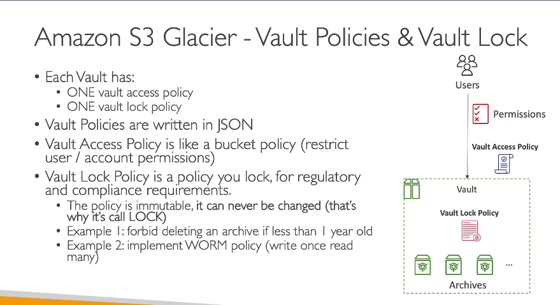
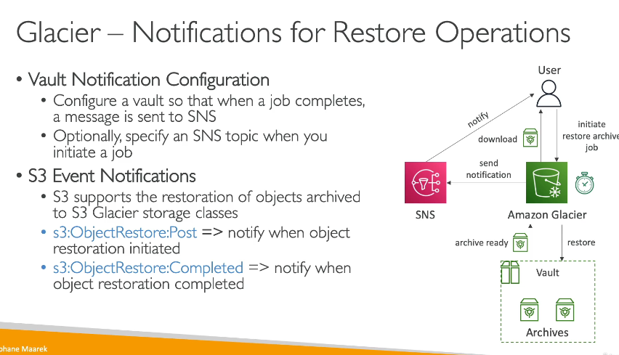

Step 1: Upload an Object to S3 Glacier
We will store an object in an S3 bucket and transition it to Glacier storage.
Set Lifecycle Rule to Automatically Move Files to Glacier
You can create an S3 Lifecycle Rule so that files older than a certain period move to Glacier.
- Go to AWS S3 Console → Select your bucket
- Click on Management → Lifecycle Rules → Create Rule
- Set Transition Policy:
  - Move objects to Glacier after 30 days
  - (Optional) Move objects to Deep Archive after 180 days
- Save the Rule

Step 2: Initiate Restore of the Object
Since objects stored in Glacier are not immediately available, we need to restore them.
Step 3: Notify When Restore is Complete
We will set up an S3 Event Notification to send a message to Amazon SNS when the object is restored.
🔹 Steps to Set Up an S3 Event Notification
1️Go to AWS S3 Console → Select your S3 Bucket
2️Click Properties → Scroll down to Event Notifications
3️Click Create event notification
4️Name: Glacier-Restore-Complete
5️Event Type: Select "S3:ObjectRestore:Completed"
6️Destination: Choose Amazon SNS
7️Create a new SNS topic (or select an existing one)
8️Subscribe your email to the SNS topic to get notified
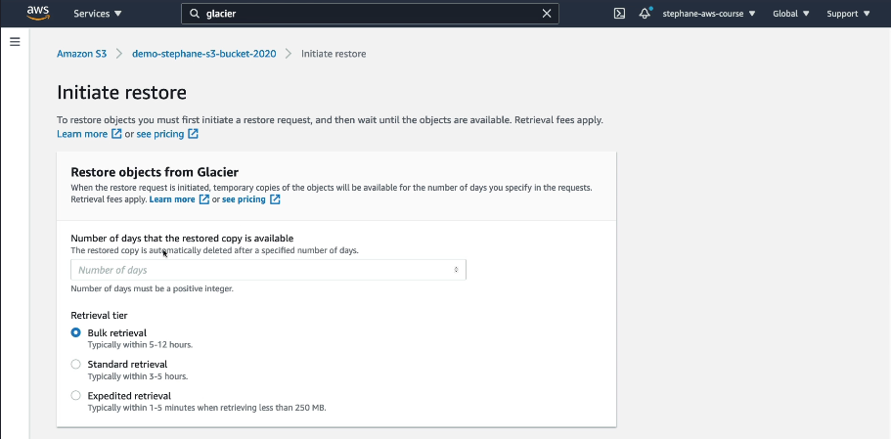

Glacier Vault Lock – Secure Your Data with Compliance Controls
Amazon S3 Glacier Vault Lock helps you enforce compliance policies on your data stored in a Glacier Vault. Once locked, the policy cannot be changed, ensuring long-term data retention and security.

✅ Why Use Glacier Vault Lock?
- Prevent Accidental Deletion – Lock data for a fixed retention period.
- Regulatory Compliance – Meet legal requirements (e.g., SEC Rule 17a-4, GDPR).
- Immutable Storage – Once locked, no one (even AWS account admins) can change it.

📌 Scenario: Protecting Legal Documents from Deletion
Imagine you're working for a financial company that must store customer records for 10 years due to legal requirements. You cannot delete or modify these records once they are stored.
Your goal is to lock these records in Amazon S3 Glacier so that no one (even administrators) can delete them before 10 years.

Step 1: Create an Amazon S3 Glacier Vault
1️Go to AWS Console
- Open the AWS Management Console.
- Search for Amazon S3 Glacier and open it.
2️Create a New Vault
- Click "Create Vault".
- Select the AWS Region where you want to store your data.
- Give the vault a name (e.g., legal-docs-vault).
- Click "Create Vault".
✅ Vault Created! Now, you can start uploading your legal documents to this vault.

Step 2: Enable Vault Lock (Initiate Lock Policy)
1️Go to the Vault in AWS Console
- Click on the vault name (legal-docs-vault).
2️ Navigate to "Vault Lock"
- In the left menu, click "Vault Lock".
3️Define a Vault Lock Policy
- Click "Initiate Vault Lock".
- Enter a retention policy (e.g., lock data for 10 years).
📌 Example Policy:
- No one can delete records for 10 years
- Only retrieval is allowed
- No changes allowed after locking
4️Start the Lock Process
- Click "Initiate Lock".
- AWS will start a cool-off period (e.g., 24 hours to 72 hours).
✅ Lock policy is now in a pending state.

Step 3: Finalize Vault Lock (Make it Permanent)
📌 Once the cool-off period is over, you must finalize the lock.
1️Return to the Vault Lock Page
- Open the Glacier Vault in AWS Console.
- Go to "Vault Lock".
2️Confirm the Lock
- Click "Complete Lock".
- AWS will now permanently enforce the policy.
✅ Your Vault Lock is now active! No one can delete or modify data before 10 years.

Step 4: Verify the Lock Status
1️Open the Vault in AWS Console
2️Go to "Vault Lock"
3️Check Lock Status → It should say "Locked"
✅ Now, even AWS administrators or root users cannot modify the retention period.

📌 Key Takeaways
✔️ Vault Lock enforces retention rules to protect important data.
✔️ Once locked, policies cannot be changed—even by root users.
✔️ It helps companies comply with regulations (e.g., GDPR, SEC Rule 17a-4).
✔️ Manual process involves creating a vault, applying a lock policy, waiting for confirmation, and finalizing the lock.

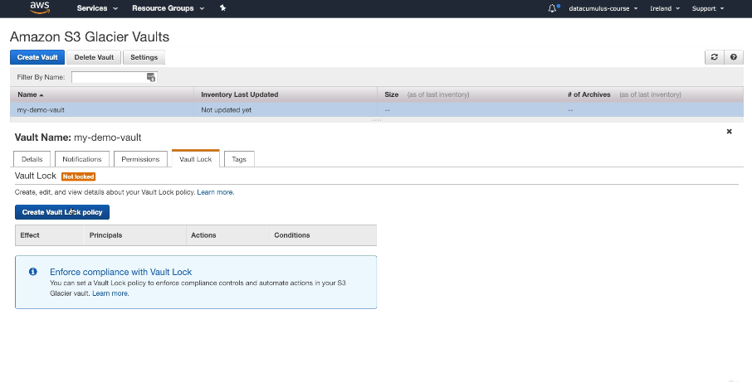

Scenario: Uploading a Large Video File to S3
Imagine you are a content creator who wants to upload a 10GB high-quality video to Amazon S3.
❌ Problem with Normal Upload:
- If your internet connection fails at 90%, you have to restart the upload from 0% again.
- The upload is slow because it sends the entire file in one request.
✅ Solution: Use S3 Multi-Part Upload!
- Breaks the file into smaller parts (chunks), like 1MB to 5GB per part.
- If the upload fails, only the failed part needs to be retried, not the whole file.
- Multiple parts can be uploaded simultaneously, making the upload faster.

Key Benefits of Multi-Part Upload
✔️ Faster Uploads – Uploads multiple parts at the same time.
✔️ Resilience – If upload fails, only the failed parts are retried.
✔️ Supports Large Files – Files bigger than 5GB must use multi-part upload.
✔️ Efficient & Reliable – Reduces the chance of upload failures.

When Should You Use Multi-Part Upload
✅ Files larger than 100MB (AWS recommends multi-part for >100MB files).
✅ When you have a slow or unstable internet connection.
✅ When you need to upload files quickly (parallel uploads).

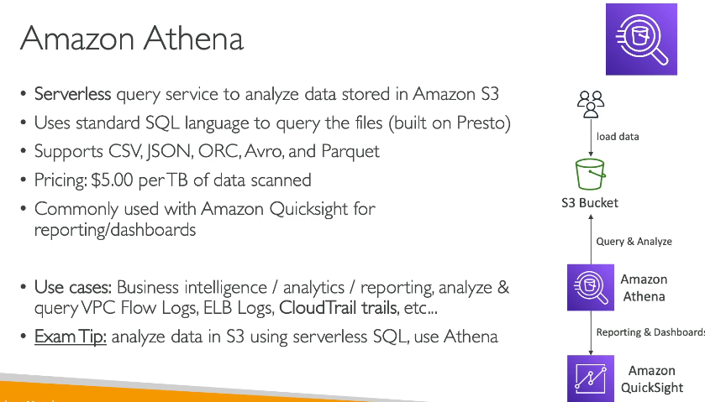
What is Amazon Athena?
Amazon Athena is a serverless query service that allows you to analyze data directly from Amazon S3 using SQL.
✅ No servers to manage.
✅ No need to load data into a database (queries S3 directly).
✅ Pay-per-query pricing (you only pay for the data scanned).

📌 How Does Athena Work?
1️Stores Data in S3 → Your data is stored in an S3 bucket in structured formats (CSV, JSON, Parquet, ORC, etc.).
2️Creates a Table in Athena → You define a schema (column names & types) for the data in S3.
3️Runs SQL Queries → You can query S3 data using standard SQL without setting up a database.
4️Athena Returns Results → It scans the data in S3 and returns query results.
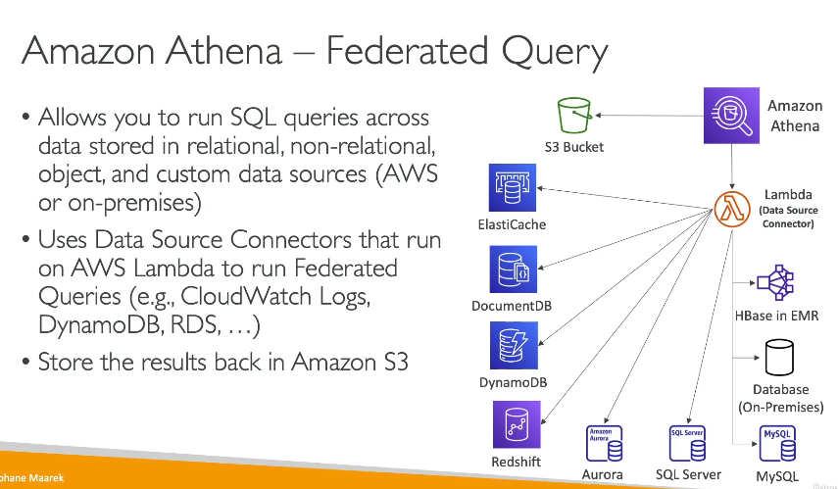
🛠 Step-by-Step Guide to Using Amazon Athena with S3 Logs
Scenario: You have web server logs stored in an S3 bucket (my-web-logs-bucket). You want to use Athena to analyze the logs using SQL.

✅ Step 1: Log Files to Amazon S3

✅ Step 2: Go to Athena Query Editor
1️Open AWS Console → Go to Athena.
2️In the Query Editor, click Settings.
3️Under Query result location, enter s3://my-web-logs-bucket/query-results/.
- This ensures query results are stored in S3.

✅ Step 3: Create a Database in Athena
1️Run the following query to create a new database:
CREATE DATABASE web_logs_db;
2️Click Run.
3️The database web_logs_db is now created!

✅ Step 4: Create a Table for the Log Data
Now, create a table that maps to your S3 log file.
1️In the Query Editor, select your database (web_logs_db).
2️Run this SQL query to create a table:
CREATE EXTERNAL TABLE web_logs (
date STRING,
ip_address STRING,
status_code INT,
response_time INT
)
ROW FORMAT DELIMITED
FIELDS TERMINATED BY ','
STORED AS TEXTFILE
LOCATION 's3://my-web-logs-bucket/';
3️Click Run → This links the table to the S3 data.

✅ Step 5: Query the Log Data Using SQL
Now that the data is in Athena, you can run SQL queries.
Example 1: Get the Total Number of Requests
SELECT COUNT(*) FROM web_logs;
Example 2: Find How Many 404 Errors Occurred
SELECT COUNT(*) FROM web_logs WHERE status_code = 404;
Example 3: Get the Slowest 5 Requests
SELECT * FROM web_logs ORDER BY response_time DESC LIMIT 5;
Example 4: Find How Many Requests Came from Each IP
SELECT ip_address, COUNT(*) AS request_count
FROM web_logs
GROUP BY ip_address
ORDER BY request_count DESC;

✅ Step 6: Visualize Data with Amazon QuickSight (Optional)
1️Open Amazon QuickSight.
2️Connect to Athena as a data source.
3️Select your web_logs_db database and web_logs table.
4️Create charts & dashboards based on the log data!

🎯 Key Takeaways
✔ No need for a database → Athena queries directly from S3.
✔ Standard SQL queries → Analyze logs like a database.
✔ Pay-as-you-go → Only pay for data scanned.
✔ Fast and scalable → Works well with large datasets.

When you use Multipart Upload in S3, unfinished parts (incomplete uploads) remain stored in your bucket, consuming storage and costing money. The best way to remove these unfinished parts automatically is by enabling an S3 Lifecycle Rule to expire incomplete multipart uploads after a specified time.

✅ Steps to Remove Unfinished Multipart Uploads Automatically
1️Go to the Amazon S3 Console
- Open the AWS Management Console.
- Navigate to Amazon S3.
- Click on your S3 bucket (where the unfinished uploads exist).
2️Configure a Lifecycle Rule
- In the bucket settings, go to Management → Lifecycle rules.
- Click Create lifecycle rule.
- Enter a rule name (e.g., Expire-Unfinished-Uploads).
- Choose "Apply to all objects in the bucket" (or specify a prefix if needed).
- Under "Lifecycle rule actions", select "Expire incomplete multipart uploads".
- Set a time period (e.g., 1 day to delete incomplete uploads after 24 hours).
- Click Create rule.

✅ What Happens Next?
- Amazon S3 will automatically remove incomplete uploads that exceed the specified time limit.
- You no longer pay for storage of unfinished parts.
- Completed uploads remain unaffected.

